Lab 2: Velocity and Pressure Measurement of Air

In this lab, we will focus on how to measure the velocity and pressure of air flow using two devices: pitot tube and manometer. Specifically, we will use these two devices together to measure the velocity of air coming out of the mouth, as if blowing out a candle. Finally, as an interesting extension, we will utilize the same equipment to give a rough estimate of our Vital Capacity.

# Pitot Tube

**Figure 1. Pitot-static tube and manometer.**

# Part I: Conceptual Questions

1. **Approximation in velocity calculation**. In this lab, we use a liquid manometer (a U-shape tube filled with liquid) to measure the pressure. By reading the height difference between left and right surfaces, we can determine the pressure difference, and therefore the velocity:

$$V=\sqrt{2g\frac{ρ_{fluid}}{ρ_{air}}Δh}$$

However, from the lab lecture we also know that one term is actually *neglected* in the derivation of this equation.

* 1. What is this term? (If you are not sure, read Page 84~85 from the [fluids textbook](http://www.efluids.com/efluids/books/Smits_text_part1.pdf))
  2. Why can it be neglected?

1. **Another Application of Bernoulli’s Equation**. We have encountered Bernoulli’s Equation during the lab lecture (and soon it will be covered in the fluid mechanics course). Apart from the experiment that we will conduct soon, there is another famous effect that can be well explained by Bernoulli’s Equation, which is called the [Venturi effect](https://en.wikipedia.org/wiki/Venturi_effect). In the figure below, we have some liquid filled in a large horizontal tube with different cross-sections (point 1 and point 2). Two vertical tubes are inserted at these two points, and the tube at point 1 has a higher level of waterline.

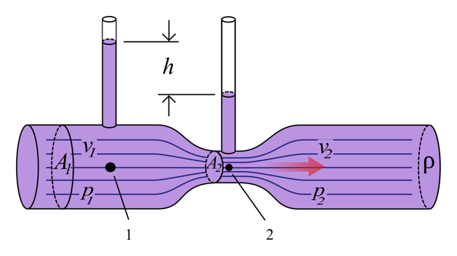

**Figure 2. A tube filled with liquid.**

* 1. By applying Bernoulli’s Equation, what can you say about the fluid velocity at point 1 and point 2? (Hint: write Bernoulli’s Equation at two locations)
  2. It turns out that we can actually measure the Venturi effect using a device similar to the one we will be using in the lab! The figure below shows an example of how it works. What’s the difference between this pitot tube and the pitot tube we are using? (Hint: think about the concept of stagnation point)

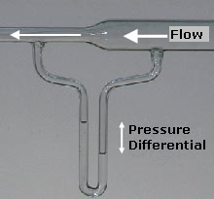

**Figure 3. a pitot tube venturi meter**

# Part II: Equipment and Observation

1. Take a closer look at the pitot tube. Why are there many small holes on the outside surface of a pitot tube? What happens if there are no holes?
2. When measuring the air velocity, make sure the two inner tubes are coaxially aligned in the center. What happens if one of them is placed off the center position? (Hint: think about the velocity profile in the small metal tube)
3. Let’s assume that we want to build a device for measuring air velocity based on the pitot tube and manometer we have in hand. We will put a scale on the U-shape tube so that we can directly get the velocity by reading the corresponding level that the waterline reaches. What would this scale look like? Will it be a linear scale, or become dense/sparse as velocity increases? (Hint: think about how one quantity varies with the other.)
4. In order to use the derived equation (from Bernoullil’s Equation) to calculate the velocity, we’ve made some assumptions on some properties of the fluid. List at least two of these assumptions. Justify why these assumptions are reasonable for our experiment.

# Part III: Experiment

## Instructions

1. Before connecting the pitot tube and the U-shape tube, fill some water into the U-shape tube. The waterline should not exceed half of the maximum length of the tube (otherwise the water may flow out of the tube), and make sure there are no bubbles by tapping the tube or keeping filling the water and squeezing out the bubbles.
2. Connect the pitot tube to one end of the U-shape tube. Make sure they are tightly connected. Check if the two small tubes inside the pitot tube coaxially aligned in the center.
3. You will need a ruler to measure the height difference of two waterlines. Some suggestions on measuring the height: You can place the ruler behind the tube and hold them together or you can mark some lines on the tube in advance. Record the height level of the waterline before blowing air. After blowing air, record the new height level. (Depending on which side of the tube you measure, it can be lower or higher than the previous level)
4. When measuring the height, try to control air flow from your mouth so that the waterline is steady enough to read the level.

## Tasks

1. Measure the velocity of air. Blow air with three different intensities and fill in the table below. **Show necessary calculation work**. If an anemometer is available, compare the measured velocity using the anemometer with the calculated result; if not, just write “N/A” in the blanks. (It’s difficult to keep the same velocity of air flow every time, so just try your best to reproduce the same velocity when measuring with the anemometer.)

Definition of quantities:

$h_{1}$: the height of waterline before blowing air (unit: cm)

$h_{2}$: the height of waterline after blowing air (unit: cm)

$Δh$: the height difference between left waterline and right waterline (unit: cm) (*Think carefully how it is related to $h_{1}$ and $h_{2}$)*

$Δp$: The pressure difference between two surfaces (unit: Pa)

$v_{1}$: the velocity of air measured with pitot tube (unit: m/s)

$v_{2}$: the velocity of air measured with anemometer (unit: m/s)

Quantities to be used:

Density of water $ρ_{w}=997 kg/m^{3}$, acceleration of gravity $g=9.8 m/s^{2}$

For density of air, you can use $ρ_{a}=1.23 kg/m^{3}$ at 20 °C and 101.325 kPa or find the right value for your environment from [Wikipedia](https://en.wikipedia.org/wiki/Density_of_air)

|  |  |  |  |  |  |  |
| --- | --- | --- | --- | --- | --- | --- |
| Index | $h_{1}$ (cm) | $h_{2}$ (cm) | $Δh$ (cm) | $Δp$ (Pa) | $v_{1}$ (m/s) | $v_{2}$ (m/s) |
| 1 |  |  |  |  |  |  |
| 2 |  |  |  |  |  |  |
| 3 |  |  |  |  |  |  |

1. It turns out that we can measure the total volume of air that comes out of our lungs by following a similar procedure (which might be a useful quantity to check if you care about your lung function during these hard times). A more rigorous term is called [Vital capacity](https://en.wikipedia.org/wiki/Vital_capacity), which is defined as the maximum amount of air a person can expel from the lungs after a maximum inhalation. However, it would require us to record another quantity: the duration of exhalation. For this purpose, we can simply use our mobile phones as a timing device.
   1. First, let’s figure out how it works. The volume of air can be obtained from integrating the volumetric flow rate over time:

$$V= \int_{t_{0}}^{t_{1}}{Q dt},$$

where Q is the volumetric flow rate (unit: $m^{3}/s$). For flat, plane cross-sections, it can also be defined as

$$Q=v⋅A,$$

where A is the cross-sectional area and v is flow velocity. This is just the velocity that we were measuring before! Then, what remains is only area and time.

* 1. Luckily, the air we blow out goes through a uniform tube, whose cross-sectional area can be easily obtained by measuring the inner diameter of the tube. For the time, we can also easily record the duration of exhalation. So, are we ready to calculate now?
  2. In fact, we need to set another limitation in order to get correct results. Remember in the derivation of Bernoulli’s Equation, we made use of an assumption of steady flow, which means the velocity is constant. However, when we blow out the air, there’s always some period of increasing and decreasing velocities, for which we can’t really apply the equation to get the velocity. Therefore, we want to try to keep the velocity constant (in other words, keep the height of the waterline constant) during the measurement. In order to reduce the error, we should make the duration of exhalation as long as possible, so keeping velocity low (corresponding to $Δh<5cm$ would be a proper choice.
  3. Finally, time to do the experiment! Remember to take a deep breath before you start ;)
  4. As a reference to check your results, the vital capacity for a normal adult is 3~5 liters. For submission, please report **all the necessary quantities** that you measured/calculated, as well as the **calculation work** for obtaining your vital capacity. For the value of vital capacity, please report in liters.